Name: _______________________________________

The purpose of this project is to synthesize the learning from the Science Unit 4 Structures and Forces
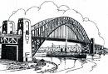
- The project will be completed individually.

- Create the lightest and strongest bridge.

- There are three components:
- Design
- Construction
- Analysis
Standards | Mark
Man-made and natural structures
Forces within or applied to a structure
Properties of Materials
Develop, Evaluate and Improve Structures
Initiating and Planning (Drawings)
Analyzing and Interpreting (Questions)
Communication and Teamwork
use appropriate language and formats to communicate ideas, procedures and results communicate using drawings. (e.g., produce a work plan that identifies criteria for selecting materials and evaluating designs)
Scientific Inquiry: (e.g., report the limitations of their designs; continue working on a problem or research project until the best possible solutions or answers are uncovered)

Due Date: ______________
Overview: Using your own design you are to build a bridge that is as strong and light as possible using only the materials you are provided with.

Problem: Build the lightest and strongest bridge.

Materials: 100 wooden skewers (can be cut) (can Be Purchased for $3.50 from Safeway)
Cardstock Paper (can be cut)
White glue or wood glue (supply your own)
Thread (supply your own)

Requirements:
Design (Initiating and Planning):
- You must include a scale drawing of your bridge.
- It must be done neatly (ruler, sharp pencil, printed in capital letters etc.).
- Must show two points of view (side and top).
- It must include the length, width and height dimensions of the bridge.
Construction:
- Must match the design.
- 63 -65 cm long, 5-7 cm wide
- Use only materials indicated
Analysis:
- Answer the analysis questions on a separate piece of paper.
- Ensure questions are related to the knowledge you have gained throughout this unit.

Procedure:
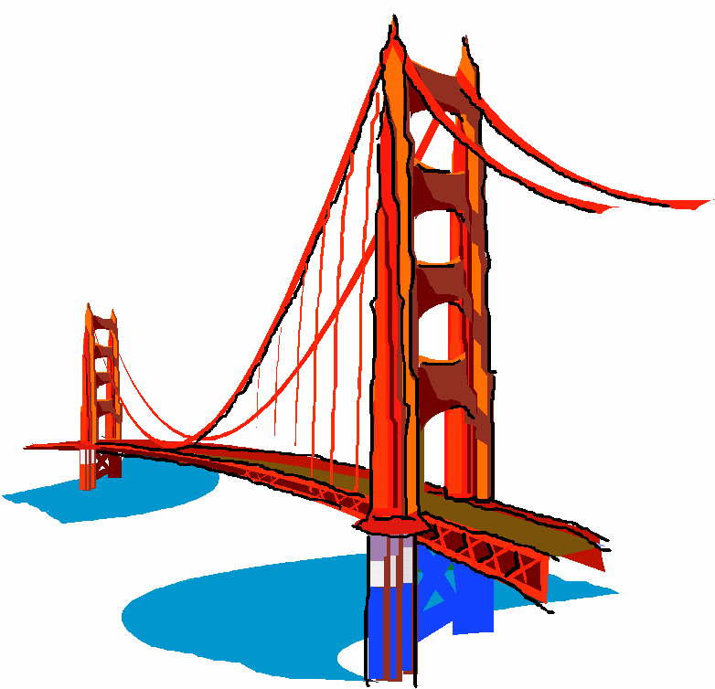
- Plan and sketch design for your bridge. In designing it, think about
how to make the bridge strong and where the weakest part of the
bridge is. Use what you have learned in this unit to increase the
strength of the bridge.
- Construct bridge using thread and glue to hold the sticks
together at the joints.
- The architect is in charge of submitting a fully detailed
drawing of the bridge.
- The bridge must be 63-65 cm long and
7-9 cm wide. Points will be deducted
for inaccurate construction. It must fit
into the wooden bridge busting platform.
- Use the Bridge Busting platform
to record the load the bridge will
support before it bends more than 2 cm.
- At the testing, your bridge will be weighed
so that an efficiency ratio can be calculated.
- Complete analysis of bridge assignment. Ensure
work is neat and readable.

Analysis:
- What type of structure have you built (mass/frame/shell)? If your structure contains elements of more than one of the types, list all and describe where each element can be found on your structure.

- On the drawing of your structure indicate places where internal forces may occur (tension, compression, torsion, shearing).

- Where are the weakest points on the structure that you have built? What could you have done to strengthen these points? (Be specific and use knowledge gained from this unit)

- List the different types of rigid joints you have included in your structure.

- What have you done to ensure that you have an aesthetically pleasing structure?

- List the different live loads and dead loads that can act on a bridge.

- Where do you think the center of gravity of your structure is? How does this make it more or less stable than other similar structures?

- In general, what did you learn from this project?

- What would you do differently next time?

