**The Science Of Ecology**

**Key Ideas:**

* The word **ecology** comes from two Greek words: *oikos* (meaning home) and *logos* (meaning to study).
* Ecology is the study of how the Earth’s **living** and **non-living** parts affect each other.
* The non-living parts are called **abiotic** – examples:
* The living parts are called **biotic** – examples:
* Living things are called **organisms** – examples:
* **Micro-organisms** are organisms that are so small that we cab only see them with a microscope – examples:
* An **ecosystem** describes the interactions of a specific group of abiotic and biotic things – examples:
* All biotic things **need**:
* food for energy – plants use sunlight
* water
* habitat – somewhere to live
* gas exchange – oxygen/carbon dioxide

**Sunlight: An Important Abiotic Factor**

**Key Ideas**:

1. Sunlight is one of the most important **abiotic factors** in an ecosystem
2. The sun determines the **temperature** of the Earth.
3. Different areas receive **more** or **less** sun – some areas are extremely hot while others stay frozen.
4. Temperature affects many things:

* how quickly water evaporates into the atmosphere – water cycle.
* the type and number of plants and animals

1. Sunlight supplies the energy for plants to carry out the process of **photosynthesis.**
2. **Photosynthesis** provides the first **consumable** energy for a **food chain**.
3. Sunlight is an abiotic factor which influences other abiotic factors and provides the energy necessary to **support all biotic** factors in an ecosystem.

**The Cycling of Water and Carbon in an Ecosystem**

**Key Ideas on Water:**

*\*\*use magnet on board to demonsrate this!*

1. Water is an important **abiotic factor** in all ecosystems.
2. Water:

* regulates climate
* carries other abiotic things

1. Water **cycles** through an ecosystem through **processes** of **evaporation**, **condensation** and **precipitation.** (p. 51, Figure 1.41)

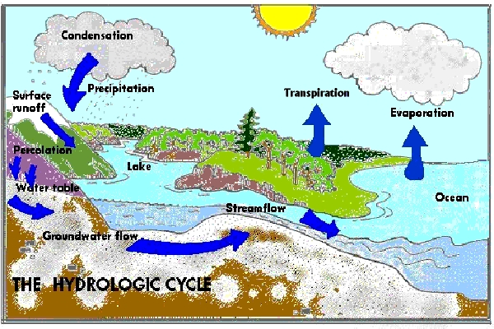

Evaporation – process of liquid changing to gas (water vapour)

Condensation – process of water vapour changing to liquid

Precipitation – process of condensation in clouds so that liquid falls as rain, snow, sleet, hail, etc.

Transpiration – process where water in plants evaporates from leaves

Ground water – water in the soil

Run off – water that moves from the ground into lakes, rivers, etc.

**Key Ideas on Carbon:**

1. Carbon is another important abiotic factor in an ecosystem.
2. Carbon exists in different forms as it cycles through an ecosystem.
3. Carbon dioxide gas
4. Carbon in sugar and starch (carbohydrates)
5. Carbon stored in plants for energy, growth and structures (carbohydrates)
6. Carbon in fossil fuels
7. The symbol for carbon is **C**
8. We will look at three cycles – two natural and one influenced by humans.

**Cycle #1:** Photosynthesis and movement of carbon through a food chain.









Plants absorb carbon dioxide (CO2) from the atmosphere and convert it into glucose (C6H12O6), a type of sugar, by a process called **photosynthesis**

**Respiration** returns CO2 to atmosphere

**Decomposition** by micro-organisms returns CO2 to atmosphere

**Cycle #2:** Photosynthesis and Fire.







Plants absorb carbon dioxide from the atmosphere and through the process of photosynthesis convert the carbon to another form and **store it**.

When plants material burns, carbon dioxide is returned to the atmosphere. Fire is a natural process.



Plants absorb carbon dioxide from the atmosphere and convert the carbon to another form and **store it**.

Cycle #3: Formation and burning of fossil fuels.











Over time, decomposed plant material made up of carbon becomes **fossil fuel**

Fossil fuel is burned releasing carbon dioxide back into the atmosphere.

## 158588

## http://www.usd.edu/esci/figures/158531.JPG

## Biotic Factors: Food Chains and Food Webs

**Key Ideas:**

1. Biotic factors include all the plants, animals and micro-organisms which live in an ecosystem.
2. We can classify biotic factors into groups:

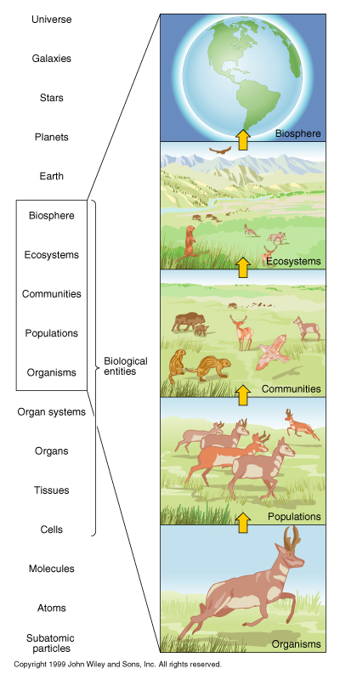

1. Ecologists who study a **population** look at one **species** of organism at a time.

Example:

1. Ecologists interested in a particular population might be studying:

* the **life cycle** of the species in question
* the **habitat** of the species in question
* size of the population and how it changes over time

1. Some ecologists study a **community** of species.

Example:

1. Community ecologists study **interactions** between species.
2. Ecologists that study **ecosystems** and **biomes** usually study how **climate change** or the **loss of a species affects an ecosystem**.
3. One way to think about **biotic factors** is to look at a **food chain**.
4. A **food chain** shows **how energy transfers from one species to another** in a community.
5. **Energy** transfers from species to species because living things **EAT**! ☺

Example:

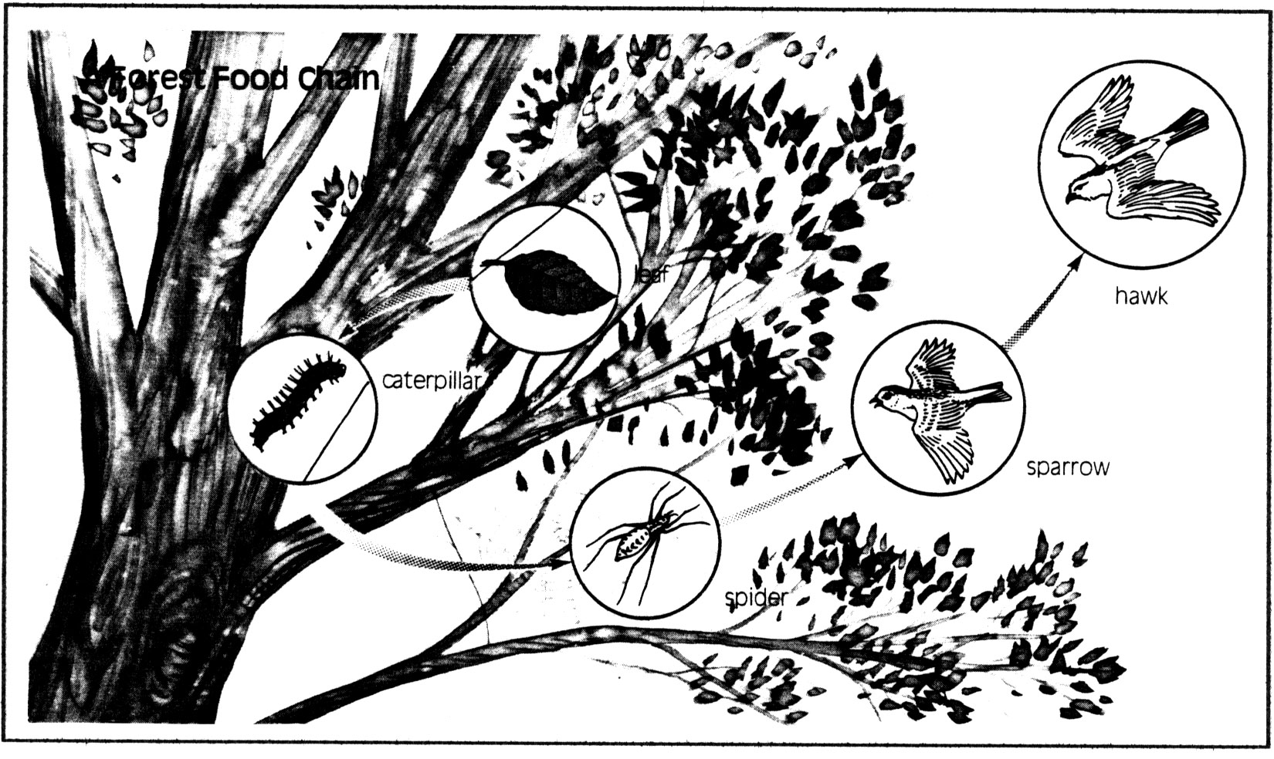

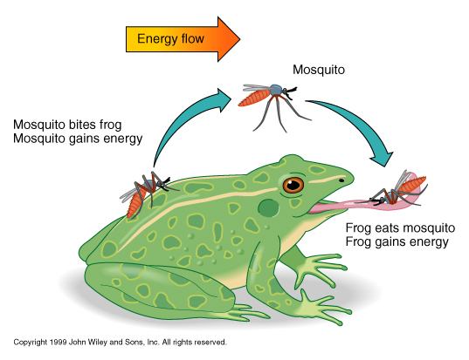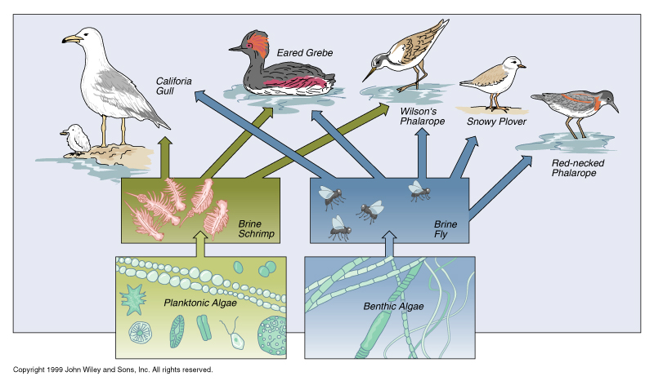**More Biotic Interactions**

**Key Ideas:**

1. There are many types of **biotic interactions** between consumers.

**Predation:**

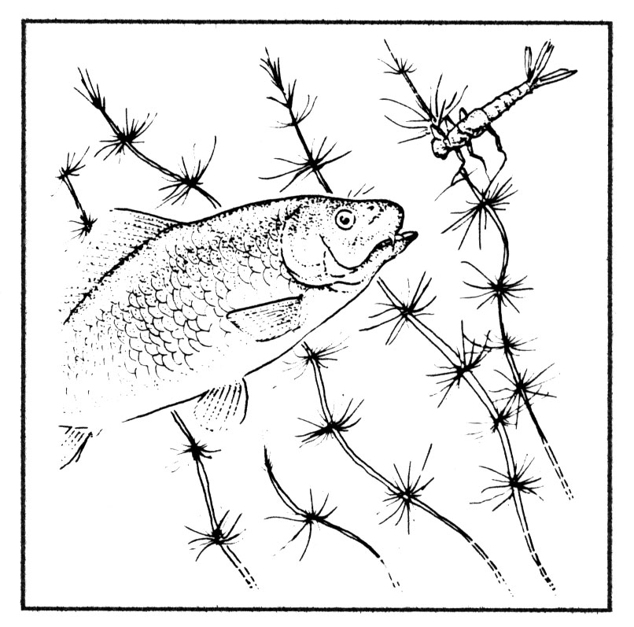

1. This interaction involves one organism, a **predator**, seeking or hunting and killing another organism, a **prey**, in order to eat it for energy.
2. Some ecologists are interested in the different **strategies predators use to hunt** their prey and the different **strategies prey will use to avoid** predators.
3. **one organism benefits** from the interaction while the **other is harmed.**

**Competition:**

1. two organism share a food source or habitat.
2. plants competing for sun will try to grow faster than other in order to shade the other plant
3. sometimes **one organisms is harmed** and the **other benefits** OR **both are harmed.**

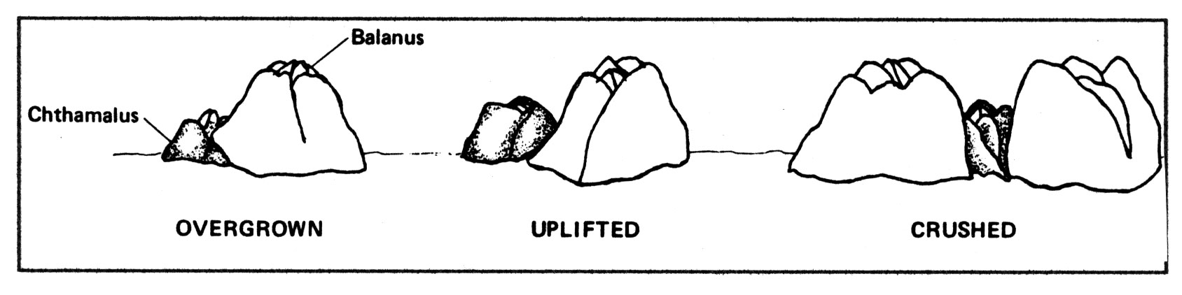

**Symbiosis:**

* there are different types of symbiosis:
  + parasitism
  + mutualism
  + commensalism

**Parasitism:**

1. involves one organism, a **parasite**, living off energy supplied by another organism, a **host**.
2. there are many different types of parasites:
3. some parasites only attach themselves **to feed** while others are **permanently** attached
4. some live attached to the **outside of the host** while others live **inside** of the host.

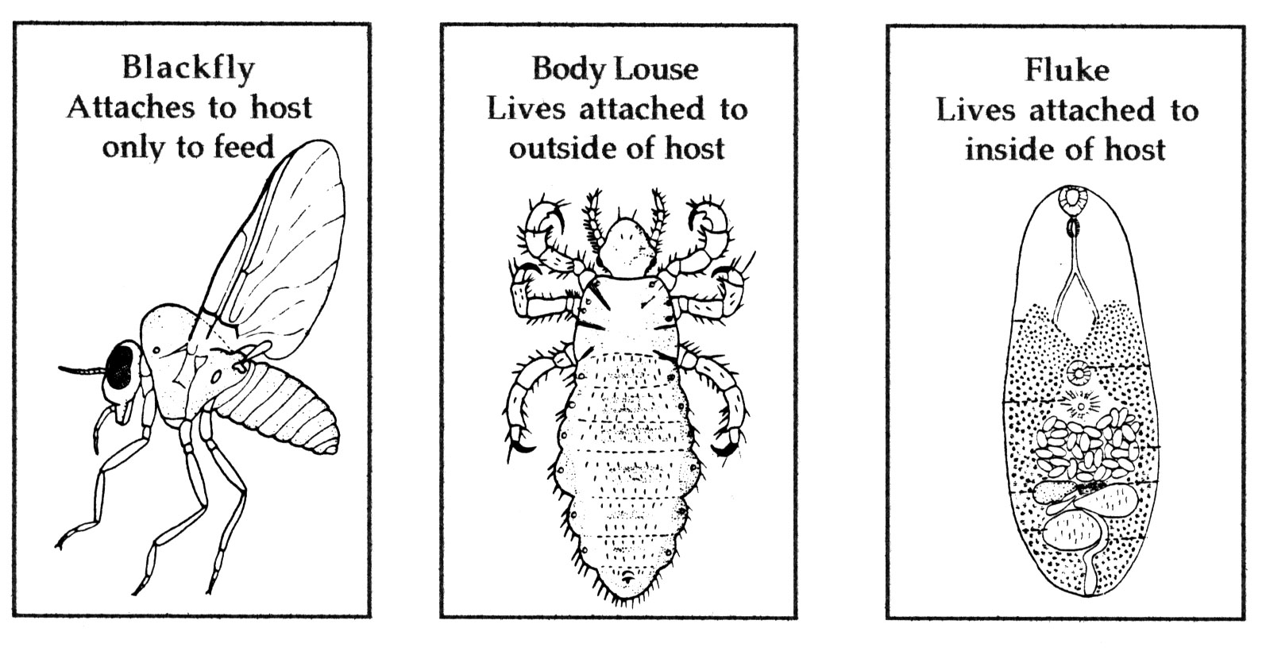

* parasites can only survive if their **host remains alive**

1. **one organism benefits** from the interaction while the **other is harmed**.

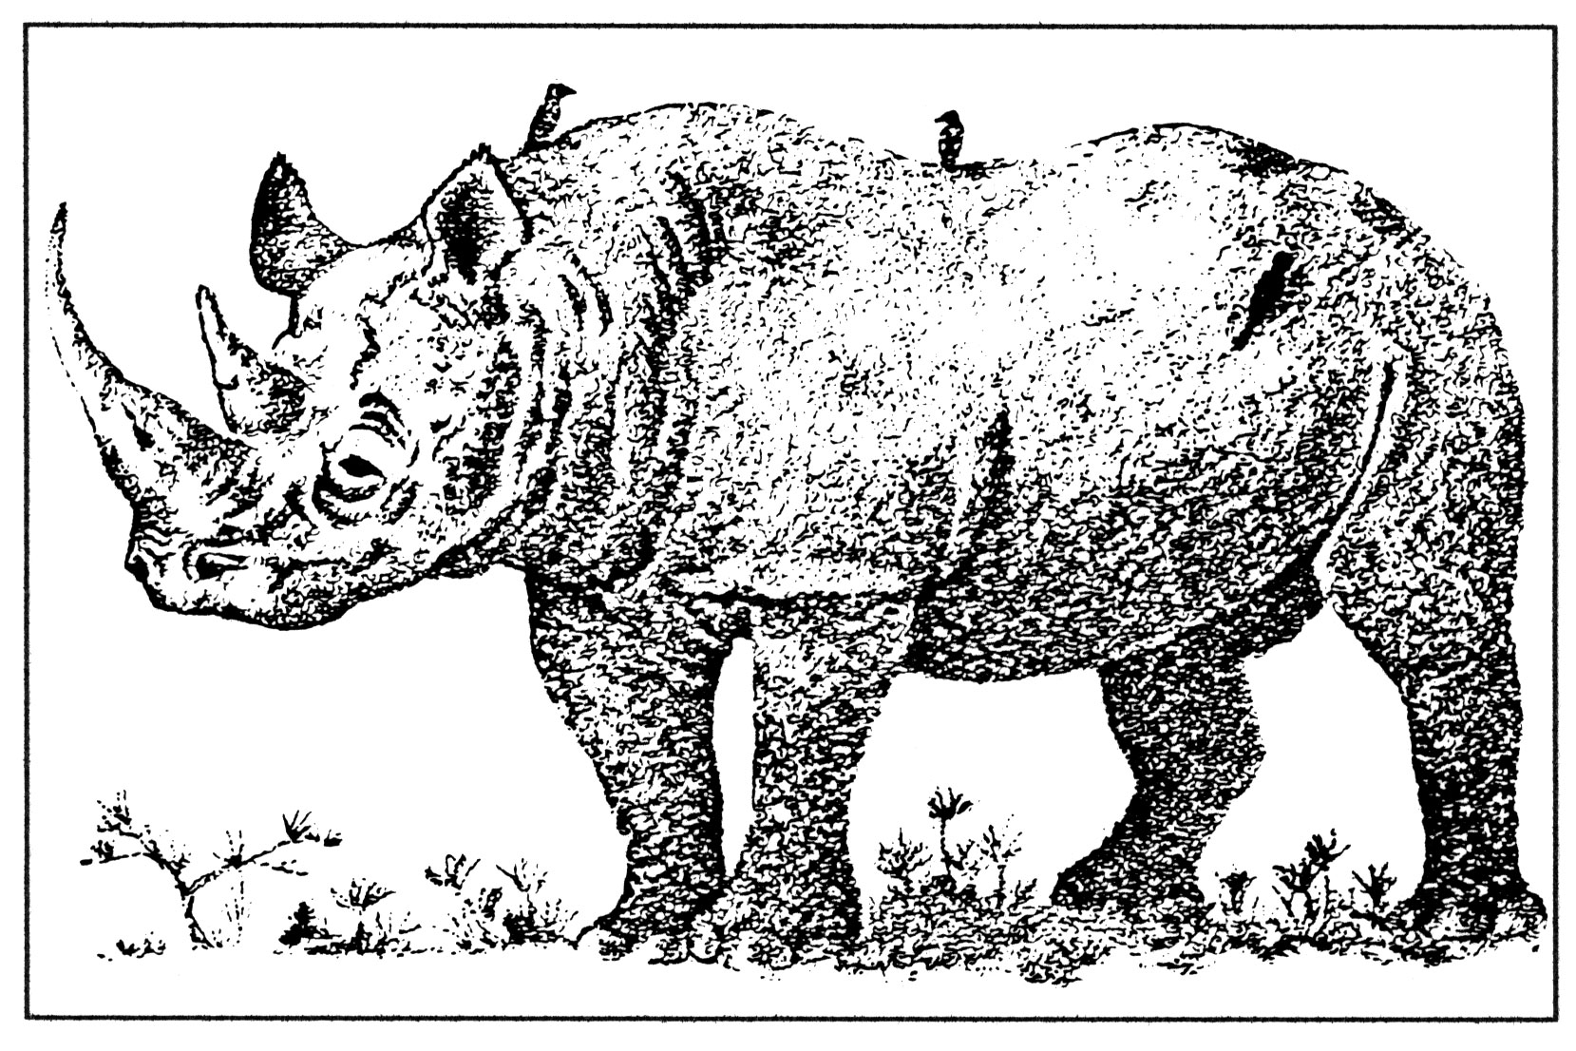**Mutualism:**

1. **two organisms** where **both benefit** from the relationship

**Commensalism:**

1. a relationship **between two organisms** where **one organism benefits** and the **other organism is unaffected**.
2. Example: a tree providing a nesting spot for a robin. The robin benefits from the tree while the tree is unaffected.

**Food Webs**

1. A **food web** is a more complete view of an ecosystem.
2. A food web describes the flow of energy among many different organisms.
3. An organism eats many different things! ☺
4. **Biomass** is a measure of the **mass** of **living** matter (*bio = life; mass*).

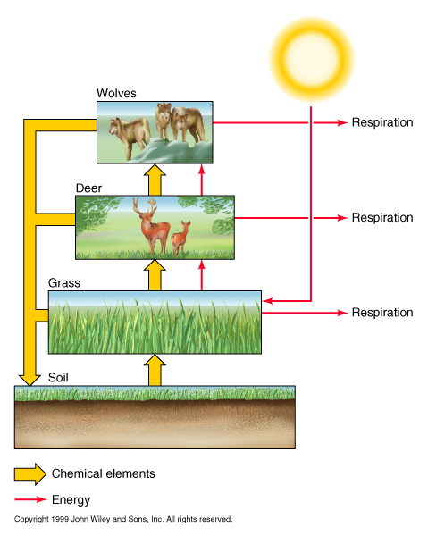

1. The **biomass pyramid** or pyramid of numbers shows **how energy moves through a food chain**.

## ::5. Interactions in Ecosystems:Ecology Images:Food Webhttp://www.usd.edu/esci/figures/158516.JPGCircle Game: Complete the Food Web

Secondary Consumer

Producer

Tertiary Consumer/Top Carnivore

Primary Consumer





**Instructions:**

Use the information in the table to draw arrows between the circles of organisms. The **arrow** should be directed **toward** the organism that is **receiving the energy**.

**Analysis of a Terrestrial Food Web:**

Draw a food web for the organisms listed in the table below.





Imagine what would happen when one animal is removed.

When mice are removed ...



**Who Are The Producers In The Ecosystem?**

**Key Ideas**:

1. Producers are the green plants and algae.
2. Producers make **the first usable form of energy**.
3. Plant cells contain **chlorophyll** (a green pigment) have the ability to perform **photosynthesis**.
4. Photosynthesis captures the sun’s energy and uses this energy to split a water molecule.



1. The **hydrogen** part of this water molecule **combines** with **carbon dioxide** from the atmosphere and forms **glucose**.



1. **Glucose** is often stored in the plant as **starch**.
2. Animals who eat plants use the energy contained in the starch.
3. This energy gets transferred through a food web.

**Who Are The Consumers In An Ecosystem?**

**Key Ideas:**

1. **Consumers** are organisms in an ecosystem that obtain energy from plants or animals.

2. In a food chain, consumers are arranged in levels.

* **herbivores**:

Decomposers











Carnivore

Top Consumer (Omnivore)

Tertiary Consumer (Carnivore)

Secondary Consumer (Carnivore)

Primary Consumer (Herbivore)

Producer

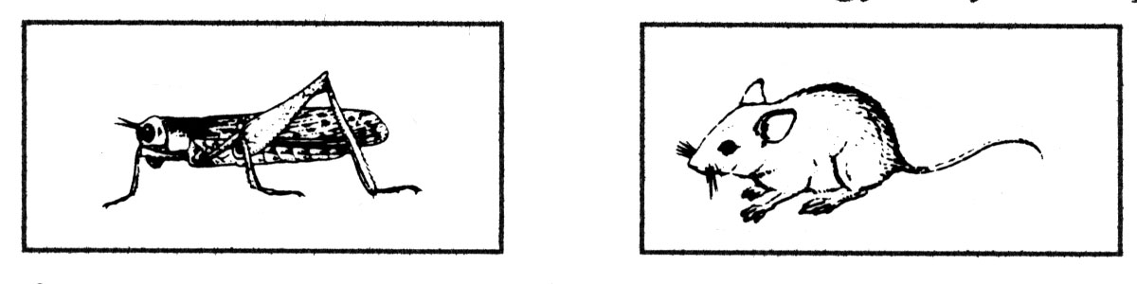

1. **carnivores**:

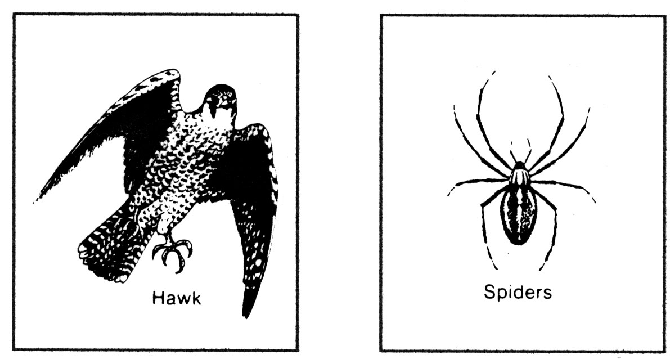

1. **omnivores:**

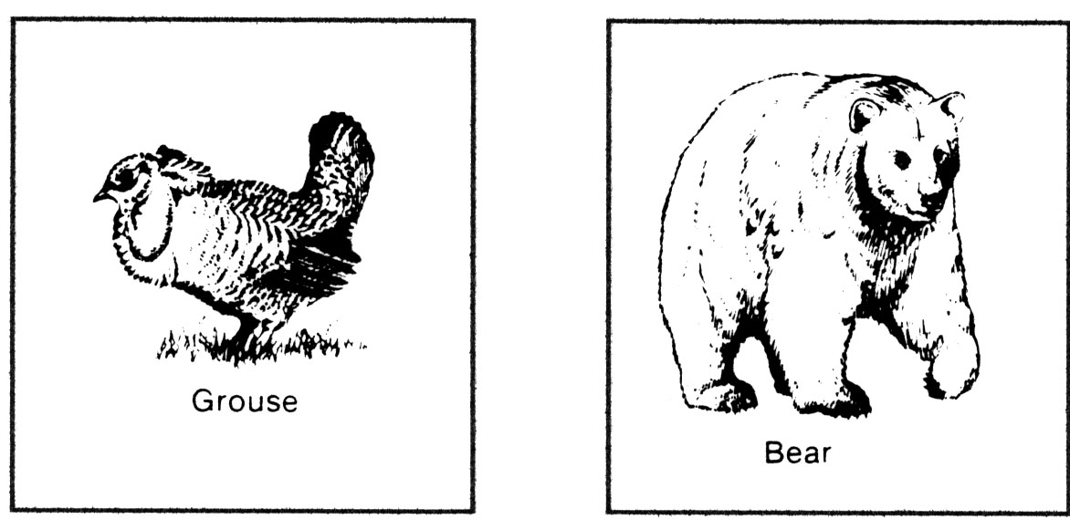

**Who Are the Decomposers In An Ecosystem?**

**Key Ideas**:

* **Decomposers** break down and feed on dead organic matter (eg. dead plants, dead animals and animal wastes)
* Decomposing organisms are mainly **bacteria** and **fungi** (eg. yeasts and moulds).
* All organisms eventually die and all organisms produce waste.
* If decomposers were not present, dead organisms and wastes would soon smother the earth.
* Decomposers return nutrients to the soil and then re-used by producers

1. Each organism has a **role** to play in the community – just like a doctor or a plumber or a student has a role in society.
2. The role of an organism in nature is called a **niche**:

## Natural Changes In An Ecosystem

**Key Ideas:**

1. Ecosystems are always changing.
2. **Some changes** in ecosystems are **natural**, while others are **human related**.
3. Changes in an ecosystem occur over **thousands of years**.
4. **Succession** describes the changes in the main **producers** of an ecosystem – how an environment ages and changes in species.
5. There **are two types** of succession:
6. Primary Succession – starting with nothing, bare rock
7. Secondary Succession – starting with some organisms
8. Succession occurs because the presence of some organisms changes the environment to allow other organisms to come in and live. (Figure 1.47, p. 56)
9. 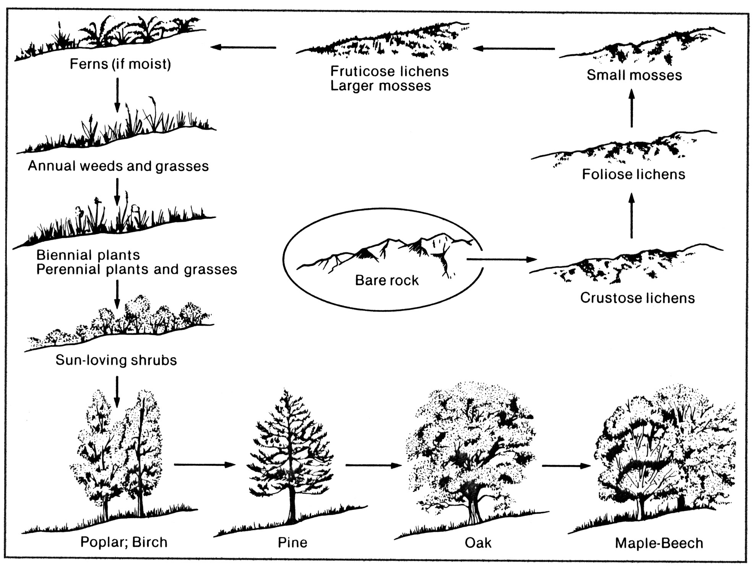The final stage in succession is called the **climax** **community**.

# Example 1: Bare Rock to Maple-Beech Forest (Primary Succession)

1. Another place were the stages of succession are clear is the **drying up of a pond**.

### Example 2: Pond to Aspen Forest (Secondary Succession)

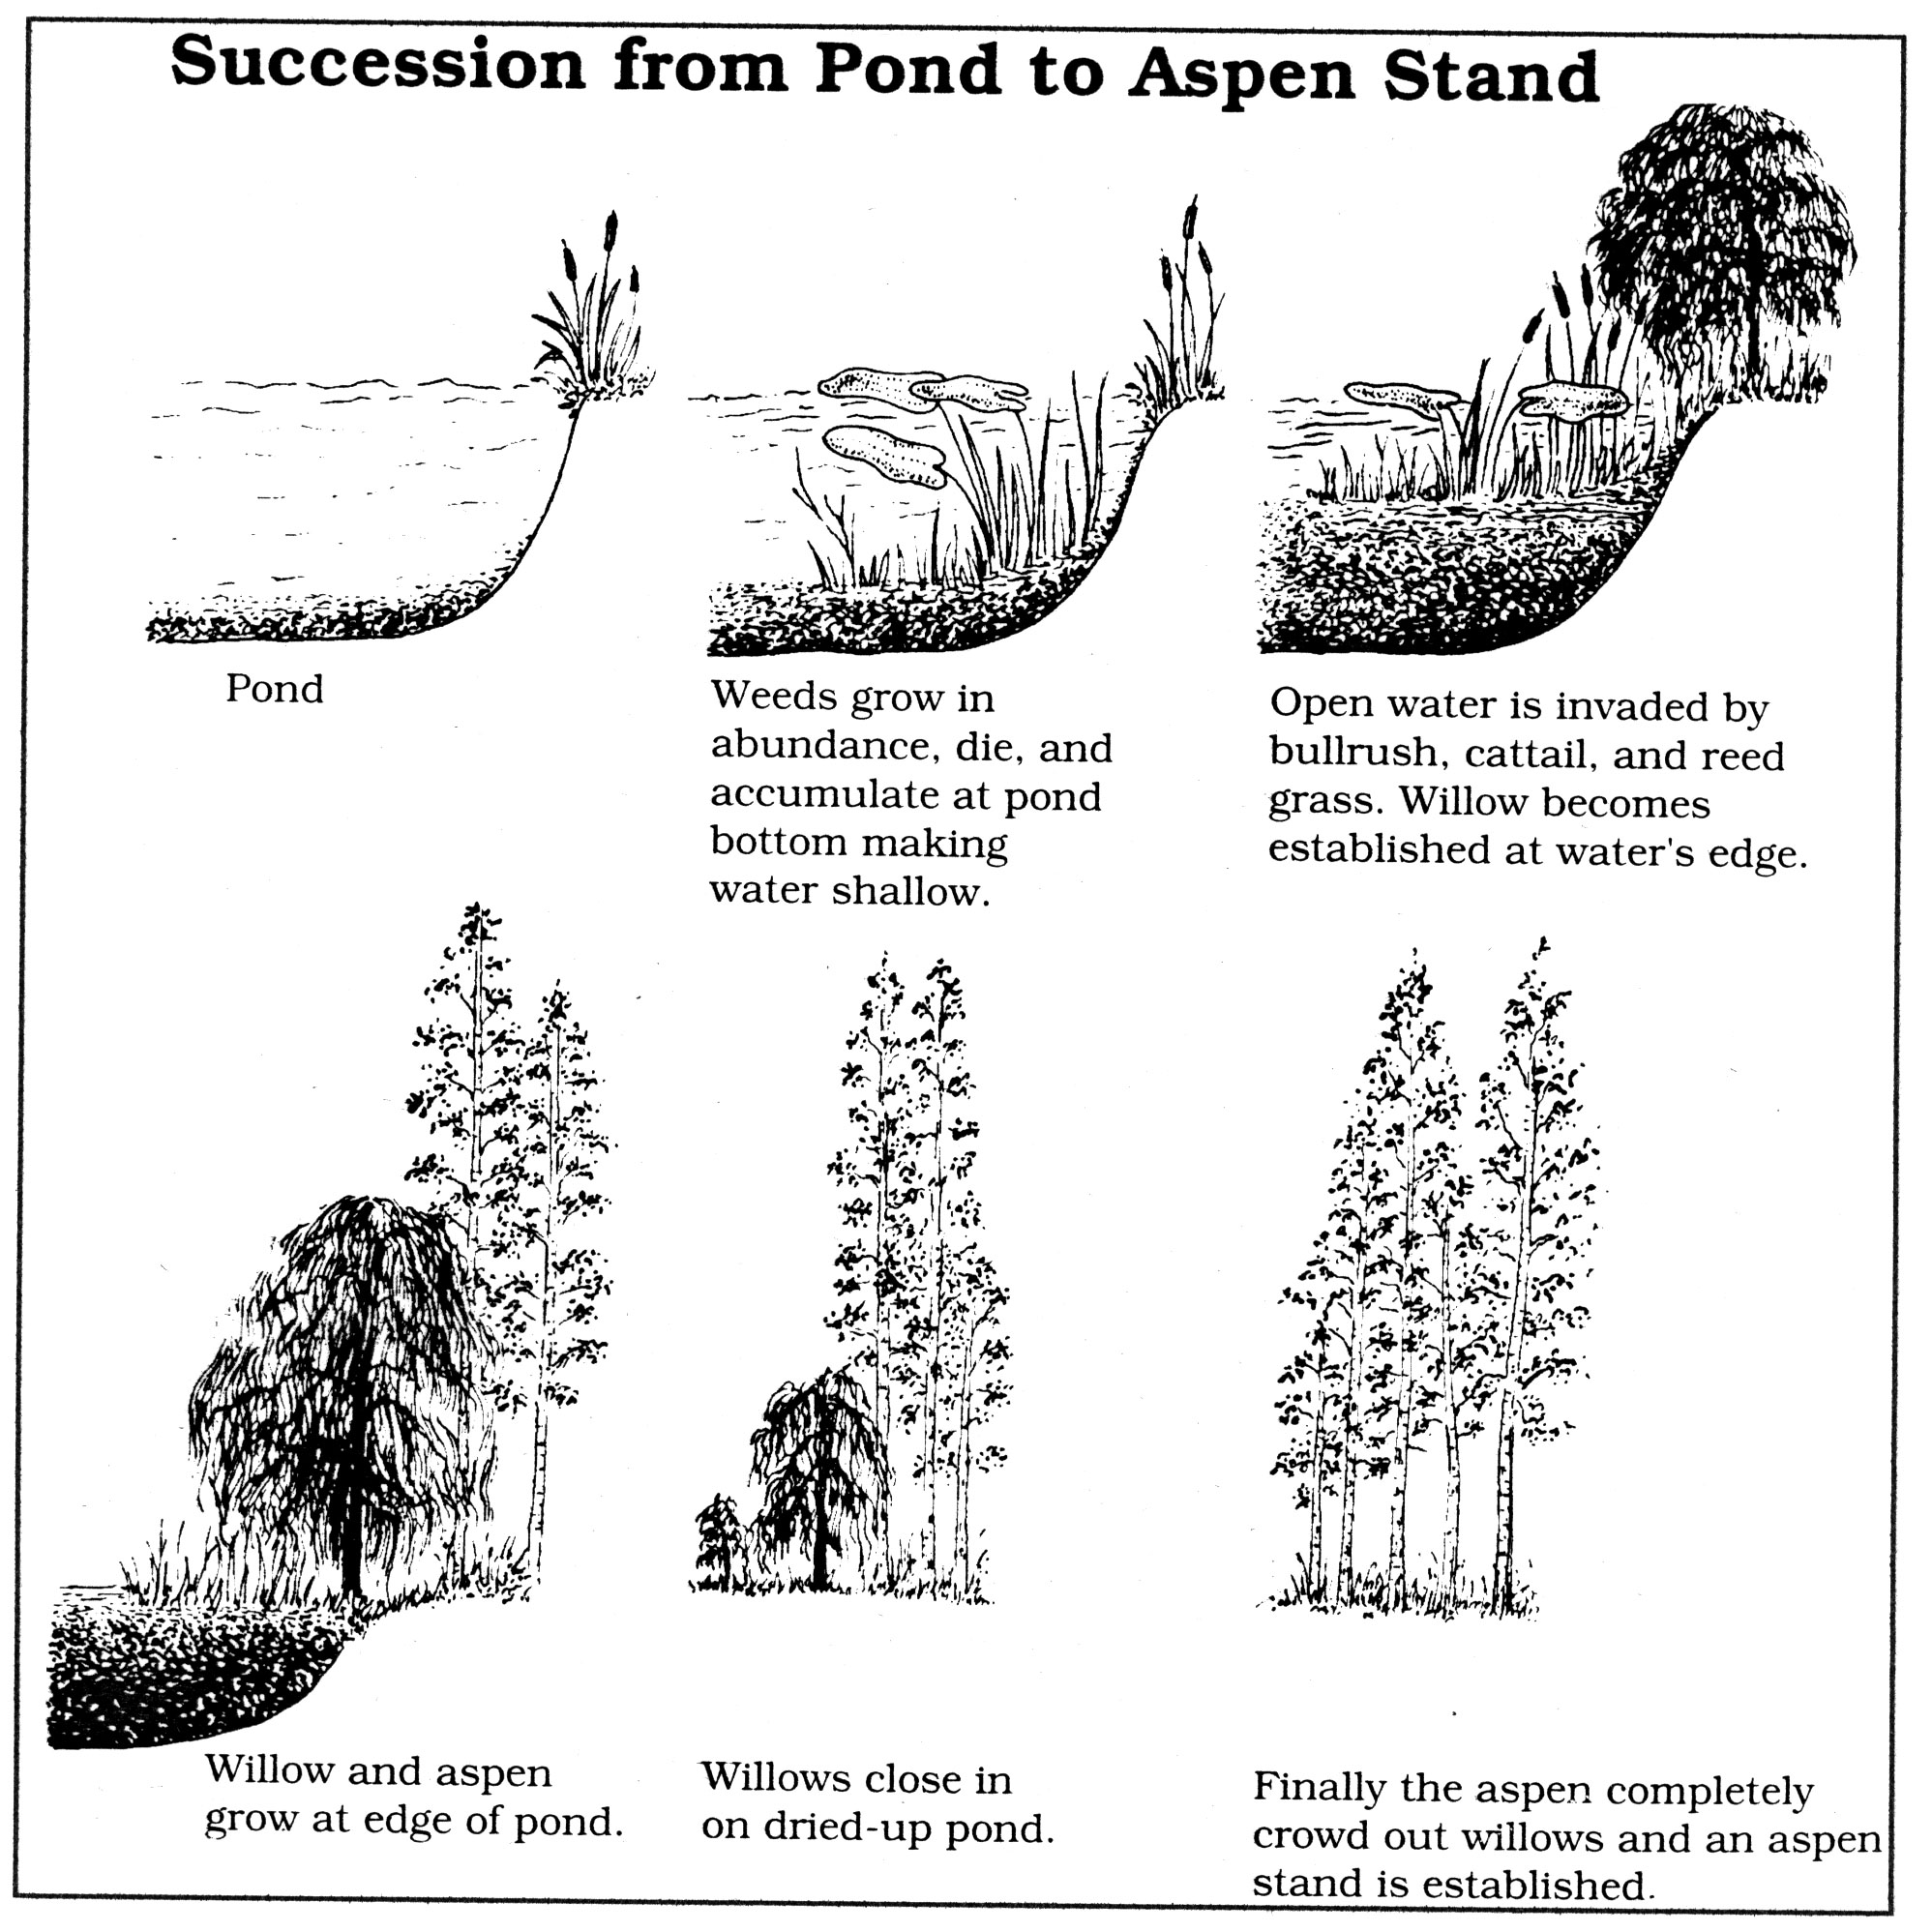

## 

in00524_**More on Human Impacts on Environment**

* We will discuss three important human impacts:

***Pollution***

1. **Pollution** occurs when a substance is in the environment that cannot be broken down, stored, or recycled fast enough.
2. Pollution can occur anywhere in the abiotic environment:

Example:

1. A **pollutant** is a substance that can cause pollution.
2. Even natural substances can be pollutants if there is too much of them and/or they are in the wrong place. (eg. carbon dioxide – acid rain, greenhouse gas etc.)
3. Most pollutants are VERY stable – they do not break down
4. Common pollutants:

* Mercury
* PCBs – polychlorinated biphenyls
* DDT – a pesticide

1. **Bioaccumulation** is the accumulation or **concentration** of pollutants in living things.
2. Bioaccumulation occurs when pollutants enter and move from level to level in the food web.
3. Bioaccumulation of mercury – p. 54

***Species Introductions***

1. A species that is brought to a new environment by humans is called an **introduced species**
2. Introduction of exotic or foreign species is sometimes **accidental** and sometimes **intentional**.
   1. Accidental – Asian carp, Zebra mussels, Rats
   2. Intentional – Cane Toads, Dandelions, Rainbow Trout
3. Sometimes, scientists want to try to control changes in an environment by introducing other organisms – this is called **biological control**.

Example:

***Habitat Loss and Species Extinctions***

1. **Habitat loss** is the human destruction of natural environments.

Example:

1. **Extinction** means that a species no longer exists
2. The **main reason for extinctions** in the last century (100 years) is due to **habitat loss** – species no longer have a place to live.

an03314_**Environmental Choices**

1. **Natural resources** are materials found in nature.
2. We use and need many of natural resources on Earth.

Example:

1. Natural resources are categorized as:
   1. Renewable – nature replaces
   2. Non-renewable – cannot be replaced
2. **Sustainability** is the ability to use natural resources so that they are replaced at the same rate that they are used.

Examples:

1. Every person uses natural resources and has an impact on the natural environment – some people have bigger impacts than others
2. An **ecological footprint** is a measure of the impact a person has on the environment based on:
   1. How much **land** you use (food, shelter, waste, etc.)
   2. How much **water** you use (drinking, washing, etc.)
   3. How much **energy** you use (heating, traveling, etc.)
3. Some ways to **reduce your ecological footprint** are:

Drive less

Eat less meat

Shorter showers

pe02504_**Environmental Monitoring**

**Key Ideas:**

1. Scientists monitor environments to check the condition of an environment (**Environmental Monitoring**) – environment doctors!
2. Just as doctors need to see you regularly, scientists must check on environments regularly.
3. Scientists monitor both the abiotic and the biotic parts of an ecosystem after a disturbance.
4. A **disturbance** could be:
5. Natural -
6. Human related –
7. Sometimes, the **absence** of organisms is a big clue!
8. **Indicator species** are species that tell scientists a lot about the condition of the environment because they are very **sensitive to changes** in the environment.
   * If present – healthy habitat
   * If absent – unhealthy habitat

Examples of indicator species:

1. To monitor environments, scientists need to decide:
2. When?
3. Where?
4. How long?

*When*

1. Scientists usually want to **compare** the environment NOW with what it was like in the PAST, before a disturbance.
2. **Baseline data** is the information on the environment BEFORE the disturbance
3. Note: baseline data is not always available!
4. Scientists want to monitor over a long period of time (**long-term data**).

*Where*

1. Environmental monitoring usually occurs on **permanent plots** or **quadrats**.
2. Permanent plots are areas where the information about the environment is gathered.
3. Scientists can come back to the same plot or site to monitor changes in the ecosystem.

**SITE B**

**SITE A**



bd05912_

bd06365_

**bd08043_**

**Check Your Knowledge on Ecology**

1. Define and give **one** example of each of the following:
   1. Producer
   2. Consumer
   3. Predator
   4. Prey
   5. Scavenger
   6. Abiotic Factor
   7. Biotic Factor
   8. An adaptation
   9. Indicator species
   10. Trophic level
2. What is the **difference** between:
   1. Tertiary consumer
   2. Secondary consumer
   3. Producer
3. Describe, in your own words, the **differences** between the 3 different **symbiotic** relationships:
   1. Mutualism
   2. Commensalisms
   3. Parasitism
4. Explain the difference between the following terms and provide an example of each:
   1. Niche and Habitat
   2. Population and Community
   3. Renewable and Non-renewable resource
   4. Primary and Secondary Succession
5. What role do the following play in the carbon cycle:
   1. Plants
   2. Fossil fuels
   3. Forests
   4. Biotic parts of the environment
   5. Forest fires
6. What are some of the ways that humans have impact the natural environment?
7. Explain the following terms:
   1. ecological footprint
   2. sustainability
   3. carrying capacity