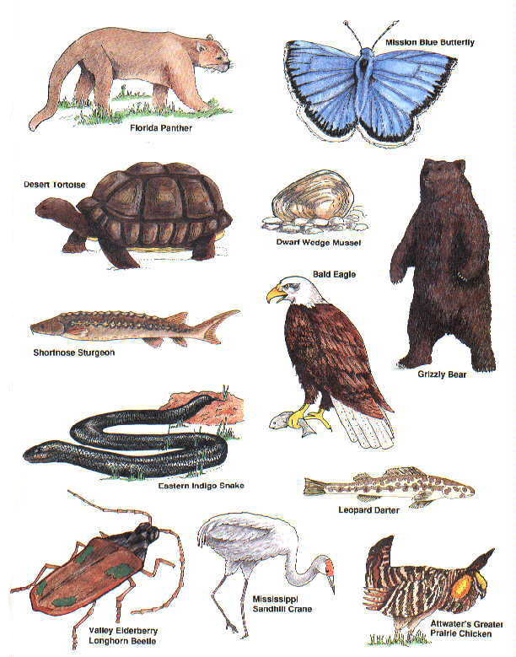
THREATENED and

ENDANGERED SPECIES
Students will research a species which is on the Alberta Threatened and Endangered Species list and then communicate their findings on that species, food chains, effects of habitat loss and other ecological concepts. Students will discriminate between good and bad website references sources. Your presentation should contain ALL of the below information.

- TITLE PAGE

- WHO?
  - Image of your species
  - Physical Description (WHAT does species look like?) Are there physical or behavioral adaptations that help the species meet its needs.

- HABITAT?
  - Geography (WHERE are species found?)
  - Homes (WHERE are species’ homes? What do their homes look like?)
  - Basic Needs (How does the habitat meet their four basic needs?)
  - Food (WHAT do species eat?)
  - Food (DESCRIPTION of food chain/web the species is part of)
  - Describe the Species NICHE in the ecosystem

- Endangerment
  - WHY is this species endangered? (Loss of Habitat? Over hunting? Pollution? Introduced Species?) Are there specific reasons?
  - How would the loss of this species impact other animals in the environment.

- Positive Human Impact
  - Suggest actions people can take to help this species survive.
  - What will you do to help protect this species?
  - Is there a happy ending for this species in Alberta? And why they need to be protective?

- Bibliography…. (1 slide)
  - Must reference all websites (were you found information)

Some Good References websites:
http://srd.alberta.ca/fishwildlife/speciesatrisk/SpeciesSummaries/SpeciesAtRiskFactSheets.aspx
http://www.pc.gc.ca/eng/nature/eep-sar/index.aspx
http://www.learnalberta.ca/OnlineReferenceCentre.aspx (ID: LA22 PASSWORD: 8372)
List of Species in Alberta

Endangered Species
1. Swift fox (Vulpes velox)
2. Bison (Bison bison athabascae)1
3. Sage grouse (Centrocercus urophasianus)
4. Piping plover (Charadrius melodus)
5. Ord's kangaroo rat (Dipodomys ordii)
6. Whooping crane (Grus americana)
7. Mountain plover (Charadrius montanus)
8. Short-horned lizard (Phrynosoma douglassi)
9. Burrowing owl (Athene cunicularia)
10. Ferruginous hawk (Buteo regalis)
11. Tiny cryptanthe (Cryptantha minima)
12. Soapweed (Yucca glauca)
13. Western spiderwort (Tradescantia occidentalis)
14. Porsild’s bryum (Bryum porsildii)
15. Limber pine (Pinus flexilis)
16. Whitebark pine (Pinus albicaulis)

Threatened Species
1. Peregrine falcon (Falco peregrinus)
2. Woodland caribou (Rangifer tarandus caribou)
3. Barren ground caribou
(Rangifer tarandusgroenlandicus)
4. Trumpeter swan (Cygnus buccinator)
5. Northern leopard frog (Rana pipiens)
6. St. Mary sculpin (Cottus bairdi punctulatus)
7. Stonecat (Noturus flavus)
8. Shortjaw cisco (Coregonus zenithicus)
9. Western silvery minnow (Hybognathus argyritis)
10. Lake sturgeon (Acipenser fulvescens)
11. Small-flowered sand verbena
(Trypterocalyx micranthus)
12. Westslope cutthroat trout
(Oncorhynchus clarkii lewisi) 2
13. Grizzly bear (Ursus arctos)

Species of Special Concern
1. Sprague's pipit (Anthus spragueii)
2. Long-toed salamander
(Ambystoma macrodactylum)
3. Long-billed curlew (Numenius americanus)
4. Loggerhead shrike (Lanius ludovicianus)
5. Black-throated green warbler (Dendroica virens)
6. Harlequin duck (Histrionicus histrionicus)
7. Bull trout (Salvelinus confluentus)
8. White-winged scoter (Melanitta fusca)
9. Prairie falcon (Falco mexicanus)
10. Barred owl (Strix varia)
11. Western blue flag (Iris missouriensis)
12. Arctic grayling (Thymallus arcticus)
13. Weidemeyer’s admiral (Limenitis weidemeyerii)
14. Western grebe (Aechmophorus occidentalis)
15. Western small-footed bat (Myotis ciliolabrum)

Data Deficient Species
1. Prairie rattlesnake (Crotalus viridis)
2. Wolverine (Gulo gulo)
3. Pygmy whitefish (Prosopium coulteri)
4. Great Plains toad (Bufo cognatus)
5. Canadian toad (Bufo hemiophrys)
6. American badger (Taxidea taxus)
7. Slender mouse-ear-cress (Halimolobos virgata)
8. Verna’s Flower Moth (Schinia verna)
9. Northern myotis (Myotis septentrionalis)

In Process
1. Yucca moth (Tegeticula yuccasella)
2. Cape May warbler (Dendroica tigrina)
3. Bay-breasted warbler (Dendroica castanea)
4. Banff Springs snail (Physella johnsoni)
5. Athabasca rainbow trout (Oncorhynchus mykiss)

 | Threatened and Endangered Species Powerpoint Rubric
CATEGORY |  | 4 | 3 | 2 | 1
Content/Accuracy  (2X) |  | All content throughout the presentation is accurate. There are no factual errors. All required information is present, plus additional information. | Most of the content is accurate but there is one piece of information that might be inaccurate. All required information is present. | The content is generally accurate, but one piece of information is clearly flawed or inaccurate. Most required information is present. | Content is typically confusing or contains more than one factual error. Some required information is present.
Text - Font Choice & Formatting |  | Font formats (e.g., color, bold, italic) have been carefully planned to enhance readability and content. | Font formats have been carefully planned to enhance readability. | Font formatting has been carefully planned to complement the content. It may be a little hard to read. | Font formatting makes it very difficult to read the material.
Use of Graphics |  | All graphics are attractive (size and colors) and support the theme/content of the presentation. | A few graphics are not attractive but all support the theme/content of the presentation. | All graphics are attractive but a few do not seem to support the theme/content of the presentation. | Several graphics are unattractive AND detract from the content of the presentation.
Science Knowlege
Standard | 4: Outstanding | 3: Proficient | 2: Adequate | 1: Beginning to Develop
STS1  Habitat and basic needs of living things. | A clear, descriptive image of the endangered species local habitat and its biome are illustrated to show the needs of the organism. | Student identifies the location, and habitat of the endangered species. The needs of the species are described. | Student indicates where the endangered species lives and outlines it’s habitat | The power point leaves the viewer wondering about basic information regarding the endangered species’ habitat.
STS2  Flow of Energy and pollutants in an ecosystem | Student has provided a clear and concise image of how energy, nutrients and pollutants flow and cycle through the ecosystem to provide the species with its basic needs and/or threat. The niche of the organism is well defined. | Student identifies the species source of energy and where it fits in the food web of its ecosystem. Identifies sources of pollution that may have lead to the endangerment. (if it is a cause). The niche of the ecosystem is described. | Student identifies the species food source and its place in the food web/chain. Information about the species niche is beginning to develop. | The food chain/web of the species is roughly outlined.
STS 4  Human impacts on an ecosystem. | Student provides a sense of hope and optimism that the endangered species can survive and thrive given changes to how humans interact with the ecosystem to preserve its place in the food web. | Student identifies why the species is endangered and describes the consequences of the loss of the species would have on the ecosystem food web. Student suggests controls and actions that can be implemented to help the species survive | Cause of Endangerment is described. Consequences of a potential loss are outlined. Actions to help the species are suggested. | The power point leaves the viewer unsure of why the species is in danger. Little or no suggestions are provided to protect the species.

Science Skills and Attitude
Standard | 4: Outstanding | 3: Proficient | 2: Adequate | 1: Beginning to Develop
Skills: Performing and Recording | Student uses a wide variety of references from different points of view. Information is synthesized and written in the students own words | Student uses a variety of references. Information is analyzed and written in the students own words | Student uses few different references. Information is paraphrased from single source. | Student cut and pasted information. Little or no personal reflection went into the information provided.
Skills: Initiating and Planning | Student has personally introduced us to an endangered species in Alberta. They have fully explained the cause of the endangerment and have created a plan that compels the reader to act to help save the species. | Student identified an endangered species and the cause of the endangerment. Student has provided steps that can be taken to assist in helping the species survive | Student has identified an endangered species and has provided an environmentalist’s solution to helping the species survive. | An endangered species was introduced. The cause of the problem and plan to help the species are vague.
Attitude:  Stewardship | Project shows personal interest and passion about the subject. Student demonstrates a sincere sensitivity and commitment toward pursing a balance between the needs of humans and a sustainable environment. | Project demonstrates sensitivity and responsibility in pursuing a balance between the needs of humans and a sustainable environment. A personal commitment towards positive action toward helping the endangered species survive is implied. | Student acknowledges negative human impacts and offers ways others should commit to saving the endangered species | Little or no compassion or acknowledgement of human fault is shown. No commitment toward saving the endangered species is implied.

