Exploring Earth: Earthquakes Name ____________________
http://www.classzone.com/books/earth_science/terc/content/investigations/es1001/es1001page02.cfm
This is on the website under landformations. Click the button called earthquakes
1. Predict where most earthquakes occur.
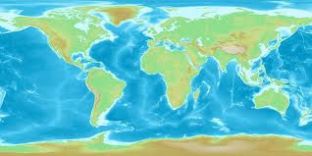
2. Describe how the pattern of earthquake locations compares to the location of plate boundaries.
___________________________________________________________
___________________________________________________________
3. Which depth range has the most earthquakes? _____________________
Which depth range has the fewest earthquakes? ____________________
4. At what type of plate boundary do you find most deep-focus earthquakes?
___________________________________________________________
5. Explain why deep-focus earthquakes occur at this type of plate boundary but not at others
___________________________________________________________
___________________________________________________________
6. Which magnitude range has the greatest number of earthquakes?
__________________ Which has the fewest? ______________________
7. Which type of plate boundary experiences the most earthquakes with large magnitudes?
___________________________________________________________
Hypothesize about why that type of boundary experiences larger earthquakes than the others.
___________________________________________________________
___________________________________________________________
8. Give three examples of damage that can occur as a result of earthquakes.
a. _______________________________________________________
b. _______________________________________________________
c. _______________________________________________________

9. Which cities are susceptible to earthquake activity? Describe the factors you considered in order to arrive at your answer.
City Why?
______________ __________________________________________
______________ __________________________________________
______________ __________________________________________
______________ __________________________________________
______________ __________________________________________
______________ __________________________________________
______________ __________________________________________
______________ __________________________________________
______________ __________________________________________

