**Types of Bridges and the Forces Acting on Them**

**Key Ideas**:

1. To an engineer, bridges offer a challenge in that they tend to bend or sway.

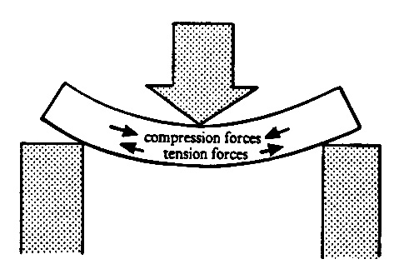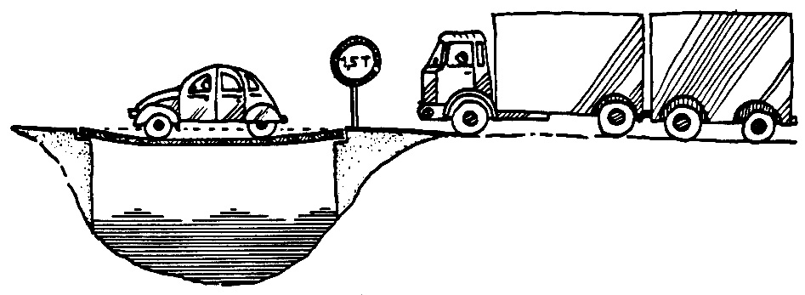

1. When something bends, it experiences **compression forces** and **tension forces.**
2. We can group bridges into four groups:
   1. **Arch**
   2. **Girder Beam**
   3. **Cantilever**
   4. **Suspension**

### Arched Bridges:

1. Some of the oldest bridges are arch bridges.
2. The “arch” may appear **above** or **below** the bridge deck.

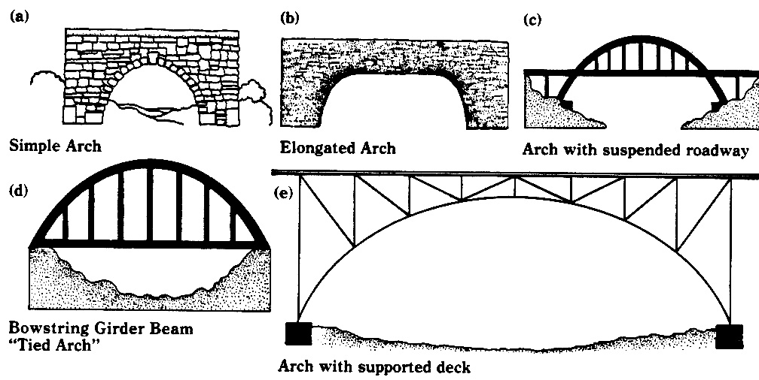

1. **Compression forces** on arched bridges are **transferred to the arch** and the **arch transfers these forces to the ground** on each side of the bridge.
2. The central stone in an arch is called the **keystone.**

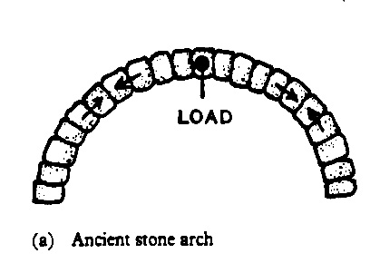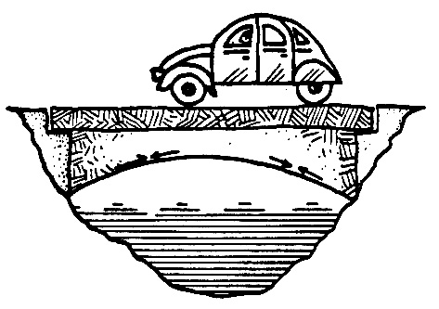

**Girder Beam Bridges:**

1. A simple **beam** bridge is flat across and supported at two ends.
2. The downward forces are **spread evenly** along its length and so, it **bends easily**.
3. 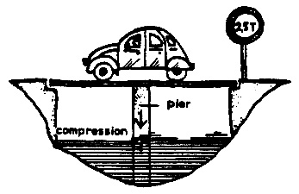Simple beam bridges are often supported by putting a **pillar** or **pier** underneath.
4. **Braces** can also be added at an angle.
5. Bracesand pillarsdirect the forces through the ends to the ground.
6. 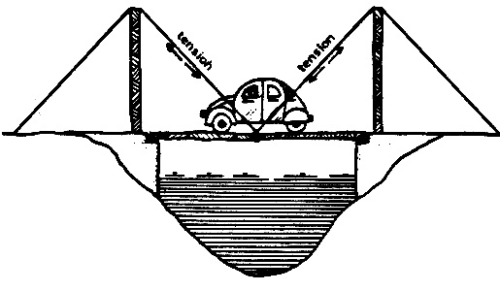Another way to stop a beam bridge bending is to use cables called **stays**.
7. **Tension** forces are **transferred to the stays**, which are strong enough to stand these forces.
8. **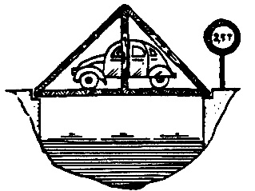Truss bridges** are designed to transfer **compression and tension forces** to the cross - beams.
9. There are many different truss designs.

**Cantilever** **Bridges:**

1. A cantilever bridge is a simple beam fixed at one end.
2. Here are some examples of cantilevers:

sg00073_dd01040_bd05645_

1. A cantilever is a **horizontal** material **supported by a very strong pier** at one end.

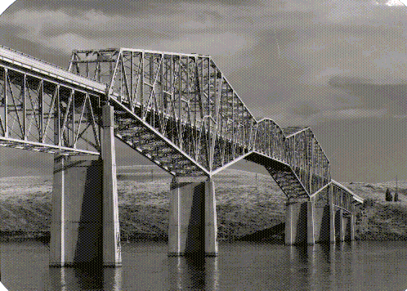

1. The strong piers balance the downward force at the center of the bridge.
2. Cantilever bridges are often used when engineers need to build over a great distance.
3. Often cantilever bridges are actually **composite bridges** because they involve other support techniques.

**Suspension Bridges**:

1. The longest bridges are often suspension bridges.
2. A typical suspension bridge has the characteristic droop between the two ends that hold it up.

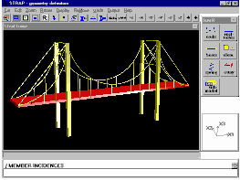

**Which is the best design?**

There are many important factors engineers must consider before deciding which bridge design to use:

1. How long does the bridge need to be?
2. What is the bridge designed to do?
3. What type of natural material is available for construction?
4. What is the type of soil?
5. Are there strong river or ocean currents or tides?
6. Will the bridge be subjected to high winds or freezing temperatures?
7. How much money is available for bridge construction and maintenance?
8. What design best meets aesthetics demands?