Topic 1: Types of Structures Name _____________________
- Pg 270: ________________ have a definite size and shape and serve a purpose or _______________.
- Every part of the structure must resist ______________ that could change its shape or size.
- The weight carried or supported by a structure is called a _____________.
- Pg 272: How a structure is put together, how it is shaped, and the materials making up the structure are all part of its _______________.
- The three designs of structures are ___________, __________ and _____________.
- Pg 273: Four main ways that a mass structure such as a sandbag wall might fail are:
  - The wall may not be _________________enough to stay in place.
  - The wall may be so heavy that the earth beneath it is ____________ _____________ unevenly (like the leaning tower of Pisa)
  - The wall may not be thick enough or fastened tightly together, so parts of it are pushed out of place. Then the structure ________________
  - The structure may not be __________________ firmly to the ground. If very large forces press against the top, the structure may tip over.
- Pg 273: Frame structures, like the body of most buildings, have a _______________ of very strong materials, which supports the _____________ of the roof and covering materials.
8. Pg 278: ________________ are hollow objects that use a thin, carefully shaped outer layer of material to provide their strength and rigidity.
- The shape of a shell spreads ____________ through the whole structure. Each part of the structure supports only a ______________ part of the load, and the complete structure can be amazingly strong.
- Pg 279: Problems with Shell structures include:
- Tiny weaknesses can cause the whole structure to ________________
- If a shell is formed from hot or moist materials, uneven cooling or drying can cause some areas to ______________ and _____________ on nearby sections.
- _____________ materials (like plywood sheets) are not easily turned into the rounded shape of a shell structure. The cost would be ___________ for a shell than for a frame.
- Assembling ____________materials into a shell is also tricky.
Picture a Frame Analyzing and Interpreting
Procedure Pg 275

1. The diagrams show a manufactured and a natural example of frame structures.

2. Find at least one place or part on each structure and mark it with
(a) rigid joint: fastens parts of the frame together so that they cannot move
(b) mobile joint: holds parts of the frame together but allows them to move or turn
(c) brace: strengthens a joint or another part that must support a heavy load
(d) rigid shape: will not collapse or change shape even when large forces push or pull on it
(e) thin, lightweight material: does not have to be an especially strong part or place
(f ) part that uses extra material for strength

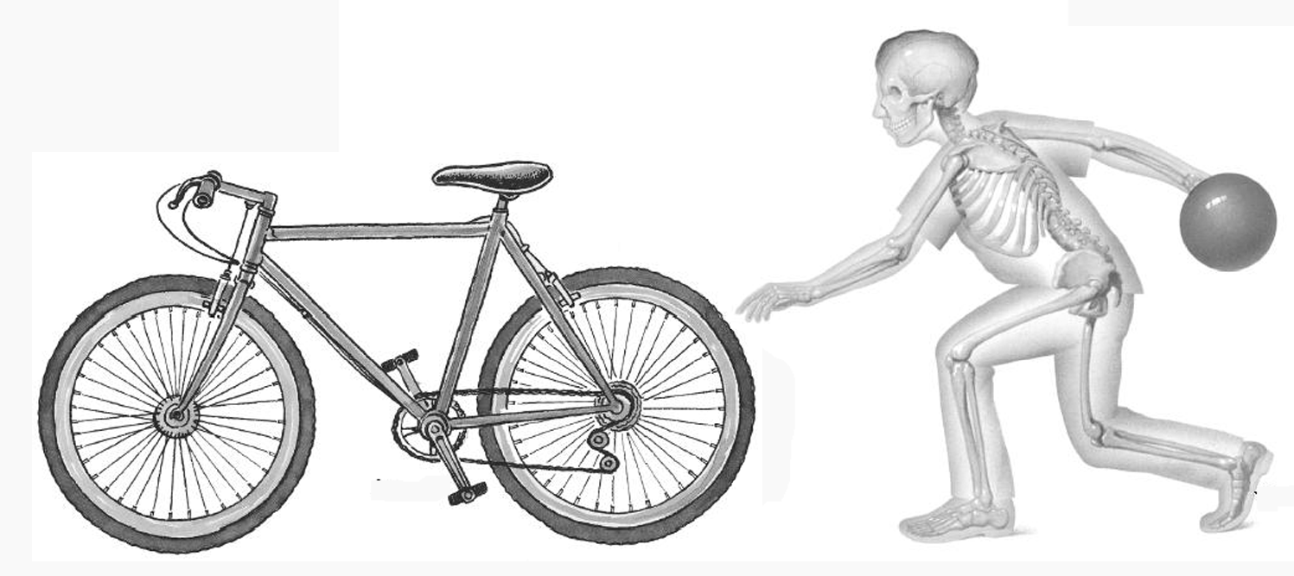

3. Describe the primary purpose or function of each frame and the primary materials from which it is made. Explain why each material is well suited for the function it is intended to carry out.

Topic 2: Describing Structures Name ____________________
1. Pg 283: Many structures have more than one ______________. Designers have a hard time creating structures that perform all of their functions ____________ well.
2. Pg 284: Designers work to a set of specifications that give _________, measurable ______________ their structure must meet.
3. __________________ is the study of beauty in art and nature.
4. Above all, architects and engineers try to keep their designs ____________________.
5. Pg 285: ________________ of ___________________ means a structure has extra strength that allows it to withstand much larger loads than it would normally need to carry.
6. _________________ _____________ is a compromise between a reasonable margin of safety and reasonable ________________.
7. Pg 286: The _______________ or characteristics of the materials must match the purpose of the structure.
8. ________________ materials made from more than one kind of material.
9. Layers of different materials, pressed and glued together, to produce useful combinations of properties are called ___________________. Plywood is an example.
10. Pg. 287: No matter how they are made, flexible materials that can be _________________ or _____________________ are extremely useful for lightweight structures
11. Pg 288-9: To pick the most suitable materials for a structure, architects, engineers, and designers consider ______________, __________________, environmental impact, energy efficiency.
12. Pg 290: Structures are often __________________ where their parts are joined together.
13. Joints that allow movement, like door hinges or your elbows are called _____________ ______________
14. Pg 290-293: List the five types of rigid joints and give an example of each.
Category of RIGID JOINT | Example

1. Name the type or types of joint described in the picture
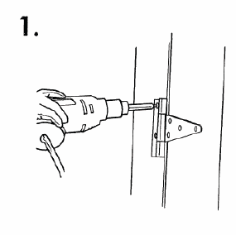 | 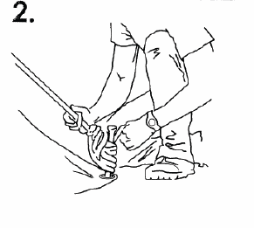
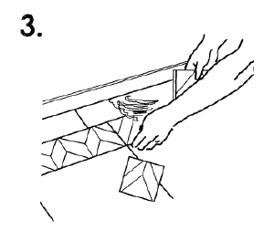 | 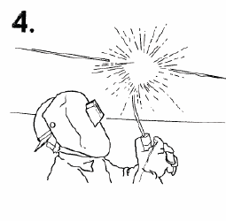

2. Indicate whether each joint is rigid (R) or mobile (M).
____(a) door hinge
____ (b) nut and bolt holding a wheel on a car
____(c) ball and socket in your shoulder
____(d) joint where the leg of a chair is fastened to the seat
____(e) ball at the end of a ballpoint pen
____(Í) joint created where the handle is fastened to a pencil Sharpener

____(g) joint created where the handlebars of a bicycle are fastened to the frame
____(h) joint created where the pages are fastened in a notebook
____(i) joint where a computer monitor is fastened to its base

